目录

1、 Scoop 安装 2

# Scoop 安装

1. Scoop 是一个 Windows 的命令行安装程序。当cmd输入时，应该出现‘PS’(should now start with "PS ").
2. $psversiontable.psversion.major 应该大于3
3. set-executionpolicy remotesigned -scope currentuser
4. iex (new-object net.webclient).downloadstring('https://get.scoop.sh')

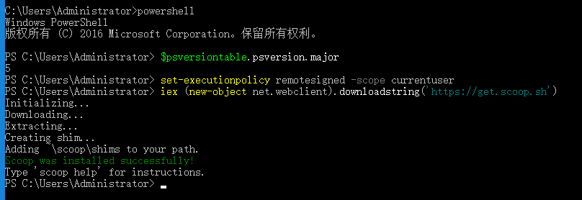

参考网站：

<https://github.com/lukesampson/scoop/wiki/Quick-Start>